Automatic Street Light

Submitted by,
Vandana Rajbhar 202504104610137
Jyoti Pal 202504104610144

Guided by,
Ms. Mubashshirahbanu Shekh



for partial fulfillment of the requirements for the Degree of Master of Computer Application, Shrimad Rajchandra Institute of Management and Computer Application, Uka Tarsadia University, April 2026

Acknowledgement
It is my privilege to express my sincere gratitude to the individuals who helped me, directly or indirectly, in conducting this project work. I would like to thank Uka Tarsadia University for including this project work activity in the M.C.A. curriculum. I am deeply grateful to our Director, Dr. Dharmendra Bhatti, and my project guide, Ms. Mubashshirahbanu Shekh, for providing the valuable guidance and suggestions necessary for the successful completion of this project. I am also indebted to all the respondents,whose cooperation made this project possible. Finally, I extend my special thanks to every faculty member of the Shrimad Rajchandra Institute of Management and Computer Application (SRIMCA), as well as my friends and family, for their constant support througoht this endeavour.

Declaration:
We hereby declare that we have read the guidelines uploaded on the website for the above said course and we shall follow those guidelines. We will not change the above-given details for the entire semester. I/We have chosen our team members by myself/ourselves. So, I/we will be responsible for team dispute, if any, during entire semester, which I/we will resolve by myself/ourselves.
We are well aware that project work must be prepared by the team members and must not be copied and (or) paid one. We acknowledge that the Institute has the authority for taking punitive actions against me for violation and/or non-compliance of the same.

Enrollment Number | Name | Signature
202504104610137 | Vandana Rajbhar
202504104610144 | Jyoti Pal

Team members were made aware by me regarding plagiarism and its consequences.

Guide Name | Signature
Ms. Mubashshirahbanu Shekh

Date:
Place: SRIMCA

INTRODUCTION
In today’s time, saving electricity has become very important, as a lot of energy is wasted unnecessarily in daily life. One common example is street lights, which often remain ON during daytime due to manual control or negligence. This leads to a significant loss of electrical energy. To overcome this problem, we have developed an Automatic Street Light System using an LDR sensor and NodeMCU ESP8266. The system works based on the surrounding light intensity. The LDR sensor detects whether it is day or night and sends the signal to the NodeMCU. When it gets dark, the system automatically turns ON the street light, and when there is sufficient light, it turns it OFF. This automatic operation reduces human effort and helps in saving electricity. The project is simple, cost-effective, and can be easily used in streets, gardens, parking areas, and other public places.

OBJECTIVES
• To save electricity by automatic control of street lights
• To reduce manual work in switching lights ON and OFF
• To detect day and night using LDR sensor
• To design a simple and low-cost system
• To improve energy efficiency
• To make the system easy to use
• To reduce power wastage in public areas
• To create an automatic lighting system
• To make the system reliable for daily use
• To understand the working of sensors and microcontroller

SCOPE
• This system can be used for street lights
• It can be used in gardens and parks
• It is useful in parking areas
• It helps in saving electricity
• It can be used on highways
• It can be used in public places
• It can also be used in residential areas
• It is useful for smart city projects
• It can be improved further using IoT
• It can also be connected with a solar system

LIMITATIONS
• LDR sensor may not always give accurate readings
• Weather conditions like rain or clouds can affect the system
• External lights (like vehicle lights) may disturb the working
• The system works only based on light intensity
• It does not have motion detection
• Proper placement of the sensor is important
• Sometimes there may be a small delay in switching
• It provides only basic ON/OFF control
• It requires continuous power supply
• The accuracy depends on the quality of the sensor

NODEMCU ESP8266
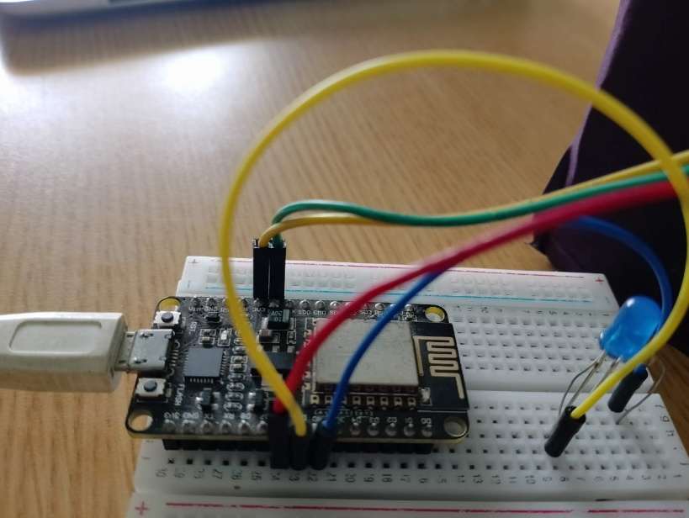

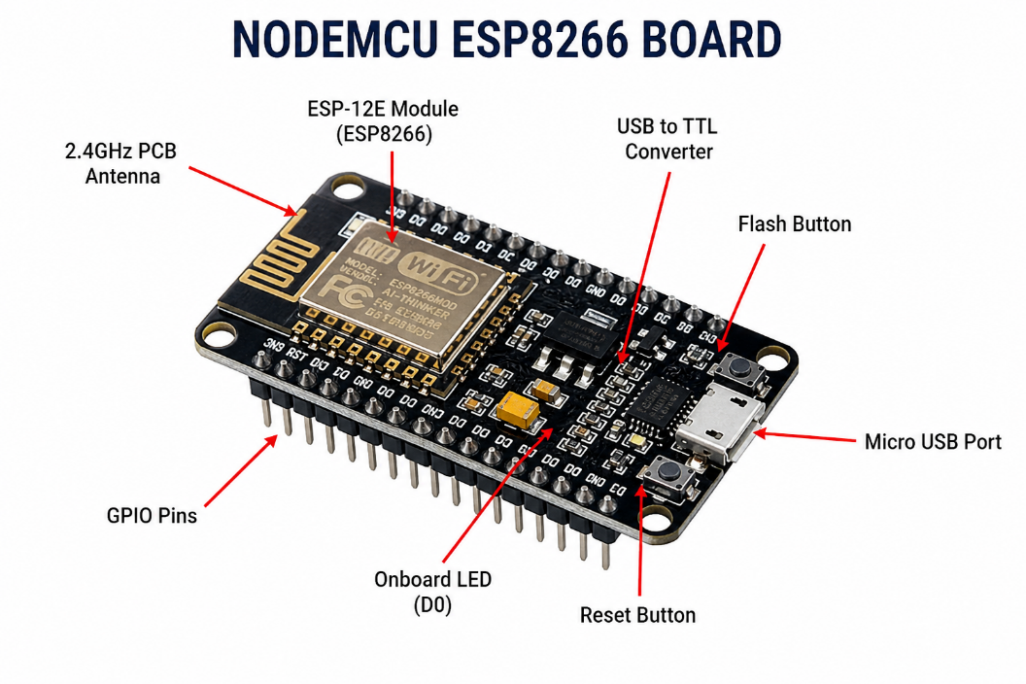

NodeMCU

ESP8266 is a low-cost Wi-Fi microcontroller widely used in IoT-based projects. It has a built-in ESP8266 chip which allows it to connect to the internet and communicate wirelessly. It can read input from sensors and control output devices like LEDs, motors, etc.

NodeMCU has GPIO pins which are used to connect different components. It can be easily programmed using Arduino IDE, which makes it simple for beginners. It also has a USB port for power supply and programming.
In this project, NodeMCU reads the data from the LDR sensor and controls the LED light based on light intensity. It acts as the main controller of the system.
Working of ESP8266
• Reads signal from LDR sensor
• Converts the analog signal into a digital value
• Processes the input data
• If light is low → LED turns ON
• If light is high → LED turns OFF
• Continuously checks the light condition

LDR SENSOR MODULE

The LDR sensor module is used to detect the intensity of light. It is based on a photoresistor, which changes its resistance when exposed to light. When the light intensity increases, the resistance decreases, and when it becomes dark, the resistance increases.
This module is easy to use because it has a built-in circuit that converts the signal into a digital output. It is commonly used in automatic lighting systems, such as automatic street lights and smart home applications.
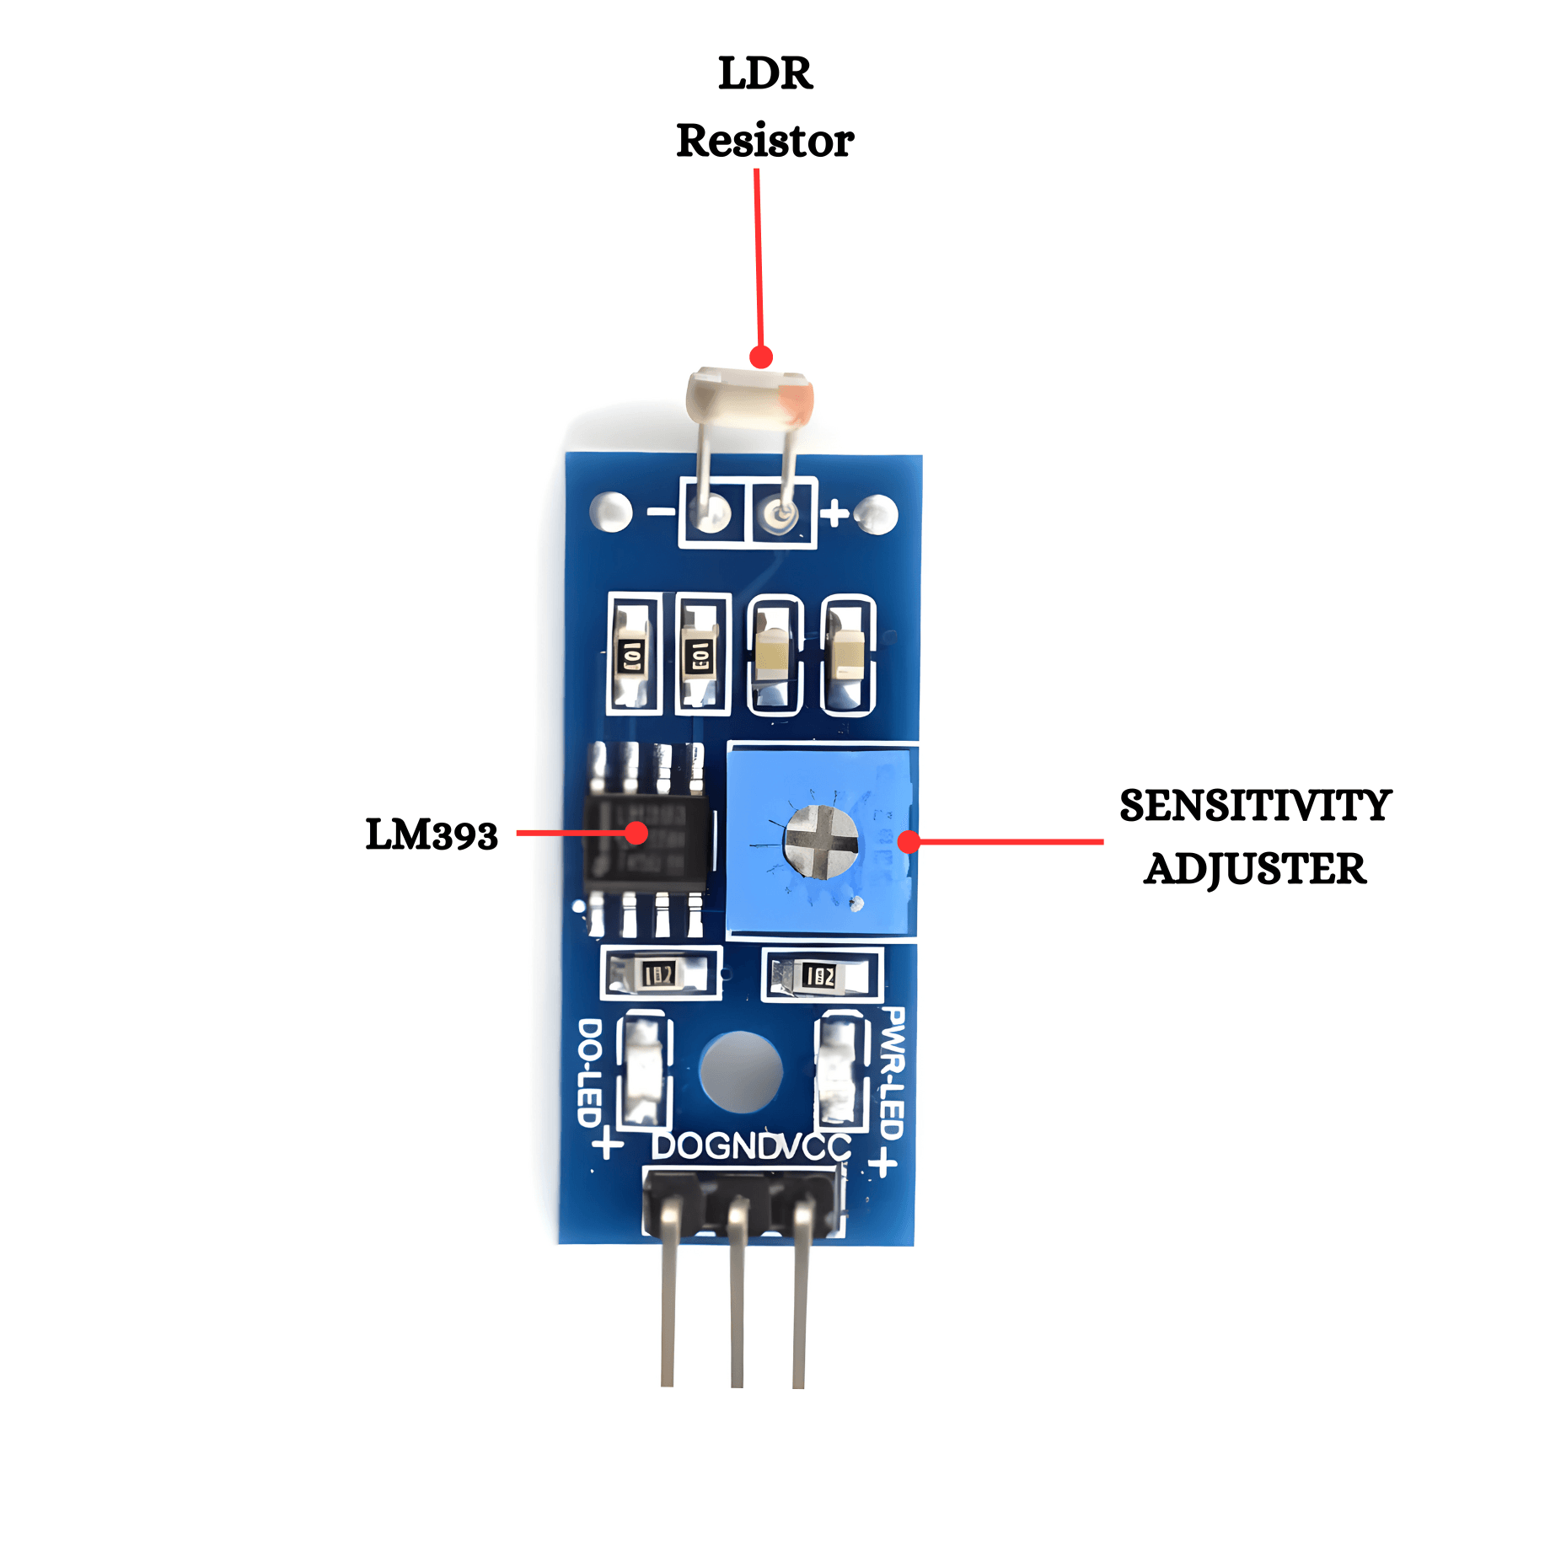

Components of LDR Module
1. Pins of the Module
• VCC – Power supply (3.3V or 5V)
• GND – Ground connection
• DO – Gives HIGH or LOW output
2. Indicator LED
Shows the output status by turning ON or OFF.
3. Potentiometer
Used to adjust the sensitivity and set the light threshold.
4. Light Sensor (LDR)
Detects light from surroundings.

Working of LDR Module
• The LDR detects the surrounding light intensity
• The resistance changes according to light
• The module processes the signal using its internal circuit
• The DO pin gives HIGH or LOW output
• The microcontroller reads this output and controls the LED

RESISTOR
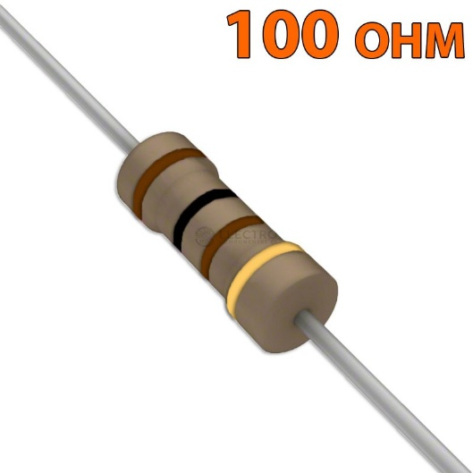

A resistor is a basic electronic component that is used to control the flow of electric current in a circuit. It provides resistance, which helps in protecting other components from excess current.
Every resistor has a fixed resistance value, which is measured in ohms (Ω). It is usually identified by color bands printed on its body. These color bands represent the resistance value.
In this project, the resistor is mainly used with the LED. It limits the amount of current flowing through the LED. Without using a resistor, too much current may pass through the LED, which can damage or burn it.
Resistors are simple, low-cost, and widely used in almost all electronic circuits. They play an important role in maintaining the proper functioning of the system.
Working of Resistor
• Opposes the flow of current in the circuit
• Reduces excess current
• Ensures components work safely
• Helps in proper functioning of LED

LED LIGHT
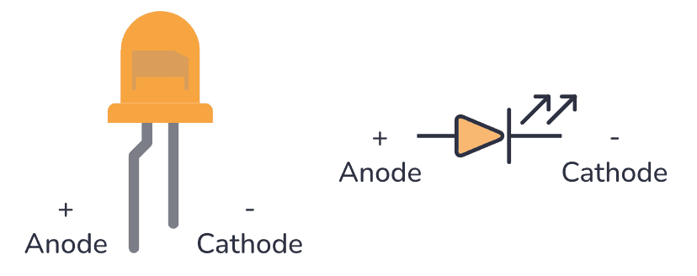
LED (Light Emitting Diode) is an electronic component that emits light when electric current passes through it. It is widely used in electronic circuits because it consumes very less power and has a long life.
An LED has two terminals: anode (+) and cathode (−). The longer leg is the anode (positive) and the shorter leg is the cathode (negative). The LED works only when it is connected in the correct direction.
In this project, the LED is used as a street light. It turns ON when it is dark and turns OFF when there is enough light. The NodeMCU controls the LED based on the signal received from the LDR sensor.
Working of LED
• Current flows from anode (+) to cathode (−)
• LED glows when current passes through it
• It works only in correct polarity
• Controlled by NodeMCU based on LDR input

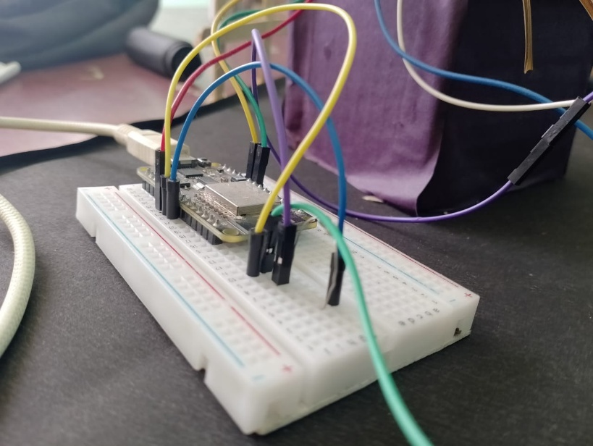
JUMPER WIRES

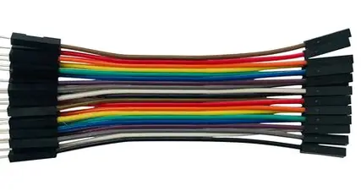

Jumper wires are simple connecting wires used to link different components in an electronic circuit. They are commonly used with breadboards to make connections without soldering.
Jumper wires are very flexible and easy to use, which makes them ideal for beginners and for testing circuits. They help in connecting components like NodeMCU, LDR sensor, LED, and power supply.
There are mainly three types of jumper wires:
• Male-to-Male – used to connect two breadboard points
• Male-to-Female – used to connect a breadboard to modules
• Female-to-Female – used to connect modules together
In this project, jumper wires are used to connect all components and ensure proper flow of current in the circuit.
Working of Jumper Wires
• Carry electrical signals between components
• Provide temporary connections
• Help in building and testing circuits easily

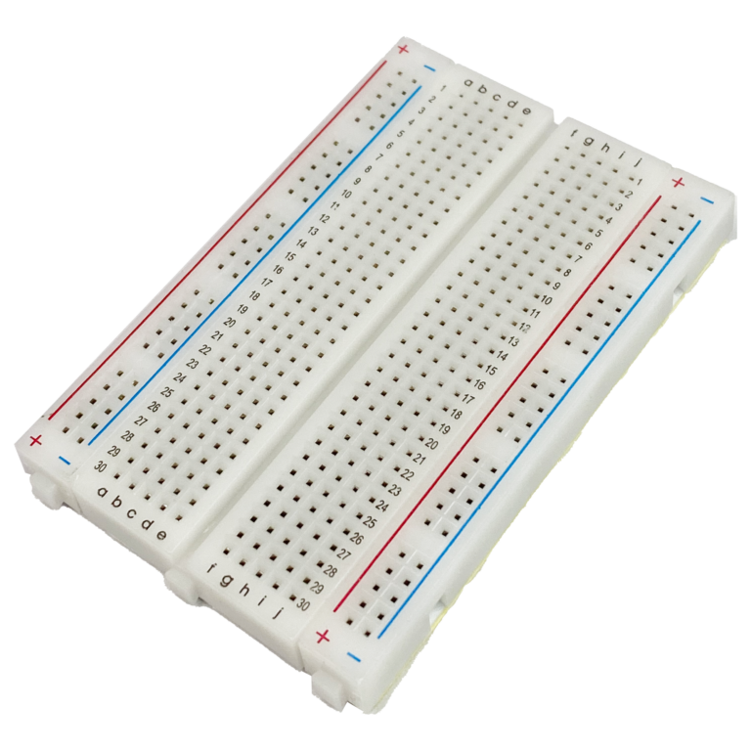
BREADBOARD

• Red line (+) → Power supply (VCC)
• Blue line (−) → Ground (GND)
• Top & bottom rows → Horizontally connected
• Middle section → Vertically connected (5 holes in one column)
• Left & right sides → Not connected
• Center gap → Used to place IC (chip)
• Same column → Internally connected
• Different columns → Not connected
• Jumper wires → Used to connect components
• No soldering needed → Easy and safe testing

TOOLS
• NodeMCU ESP8266 – To control the system and process signals from the LDR sensor
• LDR Sensor Module – To detect light intensity (day and night)
• LED – To act as the street light (output device)
• Resistor – To protect the LED from excess current
• Jumper Wires – To connect all components
• Breadboard – To build and test the circuit without soldering
• USB Cable – To power and program the NodeMCU
• Arduino IDE – To write and upload the code to NodeMCU
• Power Supply (Adapter / Laptop USB) – To provide power to the system

CODE

- Code Without cloud
// Pin Definitions
const int ledPin1 = D2;
const int ldrPin1 = D1;

const int ledPin2 = D5;
const int ldrPin2 = D6;

// Naye Pins (3rd aur 4th set)
const int ledPin3 = D7;
const int ldrPin3 = D8;

const int ledPin4 = D3;
const int ldrPin4 = D4;

void setup() {
Serial.begin(9600);

// Sabhi pins ko setup kar rahe hain
pinMode(ledPin1, OUTPUT); pinMode(ldrPin1, INPUT);
pinMode(ledPin2, OUTPUT); pinMode(ldrPin2, INPUT);
pinMode(ledPin3, OUTPUT); pinMode(ldrPin3, INPUT);
pinMode(ledPin4, OUTPUT); pinMode(ldrPin4, INPUT);

Serial.println("System Started with 4 Sensors...");
}

void loop() {
// LDR 1 Logic
int status1 = digitalRead(ldrPin1);
digitalWrite(ledPin1, status1 == HIGH ? HIGH : LOW);

// LDR 2 Logic
int status2 = digitalRead(ldrPin2);
digitalWrite(ledPin2, status2 == HIGH ? HIGH : LOW);

// LDR 3 Logic
int status3 = digitalRead(ldrPin3);
digitalWrite(ledPin3, status3 == HIGH ? HIGH : LOW);

// LDR 4 Logic
int status4 = digitalRead(ldrPin4);
digitalWrite(ledPin4, status4 == HIGH ? HIGH : LOW);

// Serial Monitor Output
Serial.print("L1:"); Serial.print(status1);
Serial.print(" | L2:"); Serial.print(status2);
Serial.print(" | L3:"); Serial.print(status3);
Serial.print(" | L4:"); Serial.println(status4);

delay(200);
}

- With cloud
// 1. Blynk ki secret details
#define BLYNK_TEMPLATE_ID "TMPL3_GMgYIFd"
#define BLYNK_TEMPLATE_NAME "AUTOMATIC STREET LIGHT PROJECT"
#define BLYNK_AUTH_TOKEN "MPrnhXBo-QCSUUyoVf6OYbKSdB-hW3Wv"

#include <ESP8266WiFi.h>
#include <BlynkSimpleEsp8266.h>

char auth[] = BLYNK_AUTH_TOKEN;
char ssid[] = "vivo 1935";
char pass[] = "Vandana4";

const int ledPin1 = D2;
const int ldrPin1 = D1;
const int ledPin2 = D5;
const int ldrPin2 = D6;
const int ledPin3 = D7;
const int ldrPin3 = D8;
const int ledPin4 = D3;
const int ldrPin4 = D4;

void setup() {
Serial.begin(9600);

// Blynk connection start
Blynk.begin(auth, ssid, pass);
pinMode(ledPin1, OUTPUT); pinMode(ldrPin1, INPUT);
pinMode(ledPin2, OUTPUT); pinMode(ldrPin2, INPUT);
pinMode(ledPin3, OUTPUT); pinMode(ldrPin3, INPUT);
pinMode(ledPin4, OUTPUT); pinMode(ldrPin4, INPUT);

Serial.println("System Started with 4 Sensors & Cloud...");
}

void loop() {
Blynk.run();
// LDR 1 Logic + Cloud Update (V1)
int status1 = digitalRead(ldrPin1);
digitalWrite(ledPin1, status1 == HIGH ? HIGH : LOW);
Blynk.virtualWrite(V1, status1);

// LDR 2 Logic + Cloud Update (V2)
int status2 = digitalRead(ldrPin2);
digitalWrite(ledPin2, status2 == HIGH ? HIGH : LOW);
Blynk.virtualWrite(V2, status2);

// LDR 3 Logic + Cloud Update (V3)
int status3 = digitalRead(ldrPin3);
digitalWrite(ledPin3, status3 == HIGH ? HIGH : LOW);
Blynk.virtualWrite(V3, status3);

// LDR 4 Logic + Cloud Update (V4)
int status4 = digitalRead(ldrPin4);
digitalWrite(ledPin4, status4 == HIGH ? HIGH : LOW);
Blynk.virtualWrite(V4, status4);

// Serial Monitor Output
Serial.print("L1:"); Serial.print(status1);
Serial.print(" | L2:"); Serial.print(status2);
Serial.print(" | L3:"); Serial.print(status3);
Serial.print(" | L4:"); Serial.println(status4);
}

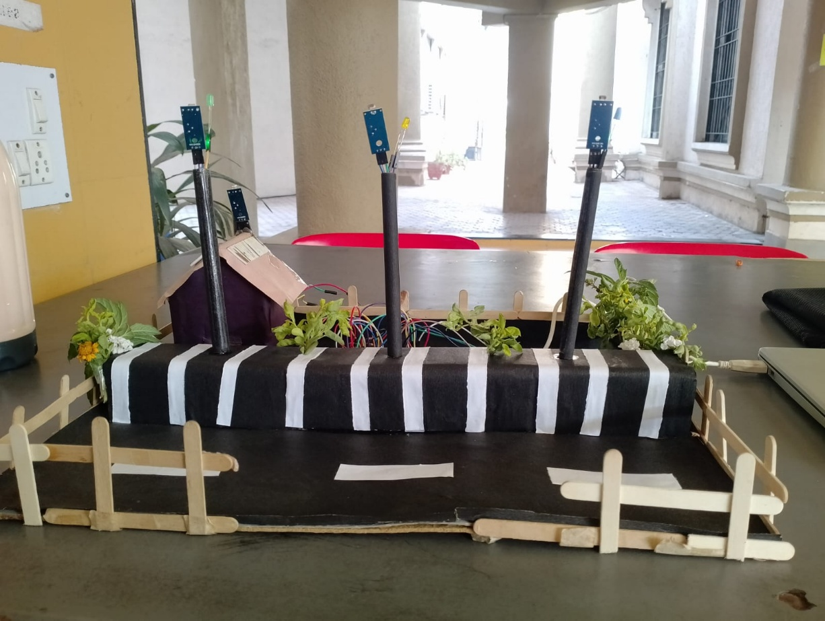
Output
